Apex Trialheads:

Write apex anonymous block to assign a numeric value value to a variable

and display repetative product of that number starting from 5 to 9

eg. if number is 12

display: 12*5=60 ....

create an Apex class Product with product name and price

Create a method call order() taking 3 parameters name,price and quantity.

this method should calculate totalAmount=price*quantity and

should return string with complete order information

[**https://trailhead.salesforce.com/en/content/learn/projects/quickstart-apex**](https://trailhead.salesforce.com/en/content/learn/projects/quickstart-apex)

**[https://trailhead.salesforce.com/content/learn/modules/apex_database](https://trailhead.salesforce.com/content/learn/modules/apex_database 2)**

**[2](https://trailhead.salesforce.com/content/learn/modules/apex_database 2) topics**

**System.debug('Hello from Apex');**

**integer num1,num2,sum;**

**num1=10;**

**num2=33;**

**sum=num1+num2;**

**System.debug('Sum of 2 numbers:'+sum);**

**string name;**

**integer age;**

**name='Seema';**

**age=21;**

**if (age>18)**

**System.debug(name+' is eligible to vote');**

**else**

**System.debug(name+' is not eligible to vote');**

**integer val,count;**

**val=12;**

**for(count=5;count<10;count++){**

**System.debug(val+'*'+count+'='+val*count);**

**}**

**MyClass obj = new MyClass();**

**System.debug(obj.getData());**

**Account acc= new Account(Name='GenPointXYZ');**

**System.debug('Account:'+acc);**

**Position__c pos = new Position__c(Name='Sr. Software Eng.');**

**System.debug('Position:'+pos);**

**List<Account> accList = new List<Account>();**

**accList.add(new Account(Name='Google Inc.'));**

**accList.add(new Account(Name='Microsoft Corp.'));**

**accList.add(new Account(Name='Capgemini'));**

**accList.add(new Account(Name='Salesforce'));**

**System.debug(accList[1]);**

**Set<Account> acc = new Set<Account>();**

**acc.add(new Account(Name='Capgemini'));**

**acc.add(new Account(Name='Capgemini'));**

**acc.add(new Account(Name='Salesforce'));**

**acc.add(new Account(Name='Salesforce'));**

**System.debug(acc);**

**Account a = new Account();**

**a.Name='Capgemini';**

**a.Rating='Hot';**

**a.Industry='Technology';**

**List<Account> accList = new List<Account>();**

**accList.add(a);**

**Account a1 = new Account();**

**a1.Name='XYZ';**

**a1.Rating='Warm';**

**a1.Industry='Education';**

**accList.add(a1);**

**System.debug(accList);**

**Map<integer,string> mymap = new Map<integer,string>();**

**mymap.put(1,'First');**

**mymap.put(2,'Second');**

**mymap.put(3,'Third');**

**System.debug('Value for key 3:'+mymap.get(3));**

**if(mymap.containsKey(4)){**

**System.debug('Value for key 1:'+mymap.get(1));**

**}else{**

**System.debug('Key does not exist');**

**}**

**StaticClass.showNum();**

**StaticClass c1=new StaticClass();**

**c1.incrementNum();**

**StaticClass c2=new StaticClass();**

**c2.incrementNum();**

**StaticClass.showNum();**

**Class1 c1=new Class1();**

**c1.showData();**

**Class1 c2=new Class1(111,'Sumit');**

**c2.showData();**

**System.debug('Time now is:'+System.now());**

**System.debug('Date is:'+System.today());**

**System.debug('User ID:'+UserInfo.getUserId());**

**System.debug('User name:'+UserInfo.getUserName());**

**System.debug('Name:'+UserInfo.getName());**

**try{**

**List<integer> numLst=new List<integer>();**

**numLst.add(111);**

**numLst.add(222);**

**numLst.add(333);**

**numLst.add(444);**

**System.debug('Data at 4:'+numLst[2]);**

**System.debug('this line will NOT be shown always');**

**}catch(ListException e){**

**System.debug('ERROR OCCURED:Array index out of bound');**

**}**

**finally{**

**System.debug('this line will always be shown');**

**}**

**class BaseException extends Exception{}**

**class OtherException extends BaseException{}**

**try{**

**integer num=-2;**

**if(num<0){**

**throw new OtherException('Balance cannot be NEGETIVE');**

**}**

**}catch(OtherException oe){**

**System.debug('Base exception caught'+oe.getMessage());**

**}**

**catch(BaseException be){**

**System.debug('Base exception caught'+be.getMessage());**

**}**

**List<account> accLst = [select a.name, a.rating, a.industry**

**from Account a where a.name like 'united%'];**

**for (Account acc:accLst){**

**System.debug('Account Name:'+acc.Name);**

**System.debug('Account Industry:'+acc.industry);**

**System.debug('Account Rating:'+acc.rating);**

**}**

1. **Getting Started with Apex**
2. **Using sObjects**

***Day 5 Assignment***

1. **Create a Visualforce page to get the Account name, Account Industry and Account Rating on a visualforce page. Create an apex class to calculate opportunity revenue. It should also display total value of account opportunity. (Make use of appropriate List object.)**
2. Create 2 Objects:
3. Customer
4. Invoice

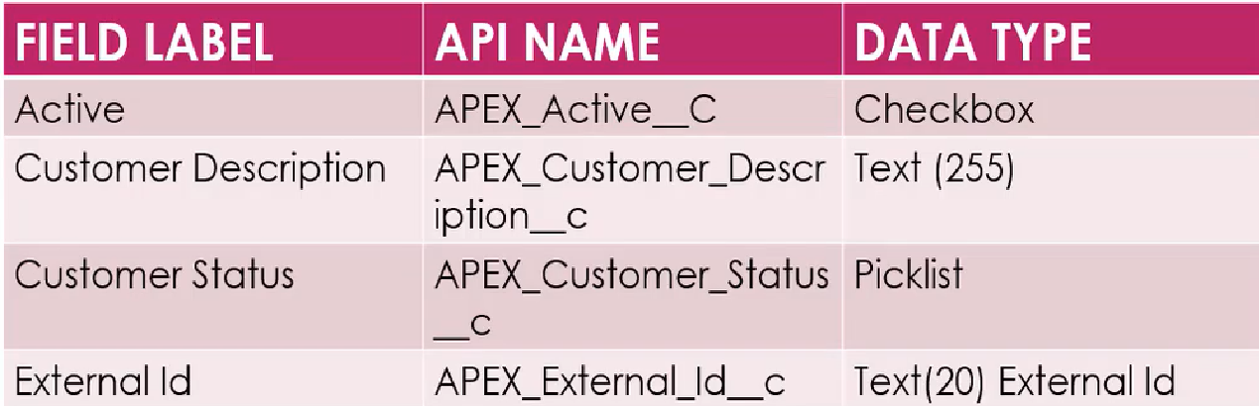

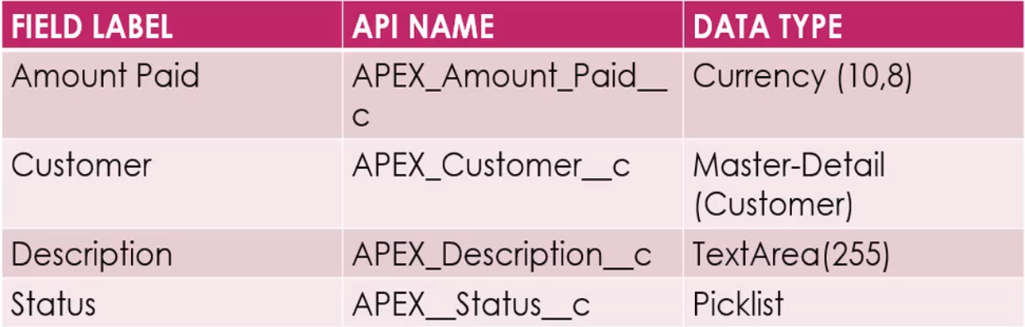

**APEX_Customer__c c1 = new APEX_Customer__c();**

**c1.Name = 'SampleCusotmer';**

**c1.APEX_Customer_Status__c='Unpaid';**

**c1.APEX_Customer_Description__c='This is a sample customer entered from apex.';**

**insert(c1);**

**APEX_Customer__c c2 = new APEX_Customer__c();**

**c2.Name = 'TwoCustomer';**

**c2.APEX_Customer_Status__c='Active';**

**c2.APEX_Customer_Description__c='This is a customer witn some invoices.';**

**insert(c2);**

**APEX_Invoice__c i1 = new APEX_Invoice__c();**

**i1.APEX_Amount_Paid__c=2000;**

**i1.APEX_Status__c='Pending';**

**i1.APEX_Customer__c=c2.id;**

**insert(i1);**

**APEX_Invoice__c i2 = new APEX_Invoice__c();**

**i2.APEX_Amount_Paid__c=1000;**

**i2.APEX_Status__c='Pending';**

**i2.APEX_Customer__c=c2.id;**

**insert(i2);**

**List<apex_invoice__c> invLst=[select iv.Name,iv.apex_status__c,iv.apex_amount_paid__c**

**from apex_invoice__c iv**

**where apex_customer__r.name='TwoCustomer'];**

**List<apex_invoice__c> UpdLst = new List<apex_invoice__c>();**

**for(APEX_Invoice__c inv:invLst){**

**if(inv.apex_status__c=='Pending')**

**{**

**inv.apex_status__c='Paid';**

**UpdLst.add(inv);**

**}**

**}**

**update(UpdLst);**

**<TO DO>**

Write an SOSL statement to find customer details (Name, status and Description)

from customer object where status is 'Pending'

Write an SOSL statement to find 'Fis*' Lead details (Name,Company,email) for all

leads with status 'Open'